- Write a program to apply texture to an Image.
let img;
let t = 0;
function preload(){
img= loadImage('brick.jpg');
}

function setup() {
createCanvas(300,300,WEBGL);
background(255);
}

function draw() {
translate(10,10)
push();
rotateZ(t * 0.3);
rotateY(t * 0.3);
texture(img);
sphere(100);
pop();
t += 0.05;
}

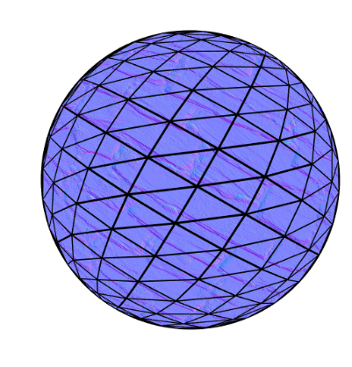
- Write a program to apply texture to Video
let vid;
let t = 0;
function setup() {
createCanvas(400, 400,WEBGL);
vid = createVideo(['Piggy.mp4']);
vid.elt.muted = true;
vid.loop();
vid.hide();
}

function draw() {
background(255);
push();
rotateZ(t * 0.2);
rotateX(t * 0.2);
rotateY(t * 0.2);
texture(vid);
box(100, 100, 100);
pop();
t += 0.05;
}
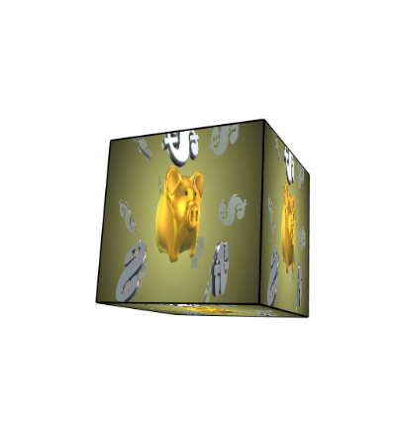

- Write a program to demonstrate different shaders.
https://itp-xstory.github.io/p5js-shaders/#/./docs/how-to-write-a-shader
https://p5js.org/reference/#/p5/texture
COLOR.FRAG
#ifdef GL_ES
precision mediump float;
#endif
void main() {
vec3 color = vec3(0.2, 0.8,0.2);
gl_FragColor = vec4(color,0.8);
}
COLOR.VERT
attribute vec3 aPosition;
void main() {
vec4 positionVec4 = vec4(aPosition, 1.0);
positionVec4.xy = positionVec4.xy * 5.0 - 1.0;
gl_Position = positionVec4;
}
P5.JS
let theShader;

function preload(){
theShader = loadShader('color.vert','color.frag');
}

function setup() {
createCanvas(100,100, WEBGL);
noStroke();
}

function draw() {
shader(theShader);
rect(0,0,width,height);
}



